COMPUTERSCIENCE REPORTFILE

ASSIGNMENT 1

***QUESTION 1) Write a program to accept two integers and print their sum.***

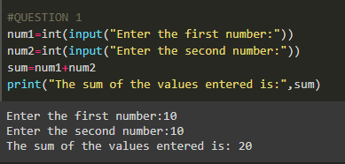

***QUESTION 2)*** ***Write a program to accept two integers and print their product***.

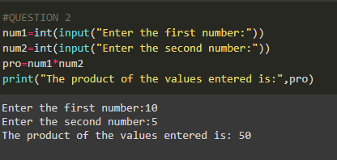

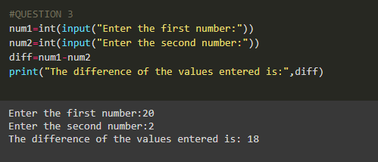***QUESTION 3) Write a program to accept two integers and print their difference of values***

***QUESTION 4) Write a program to accept two integers and print their quotient of division of values.***

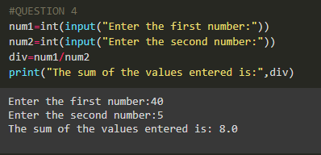

***QUESTION 5) Write a program to accept two strings and print then in a single sentence***.

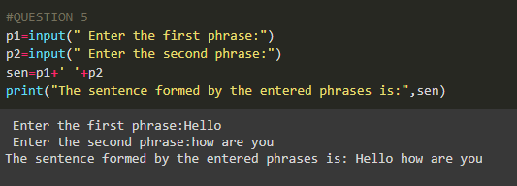

ASSIGNMENT 2

***QUESTION 1)*** ***Write a program to find average of 5 numbers.***

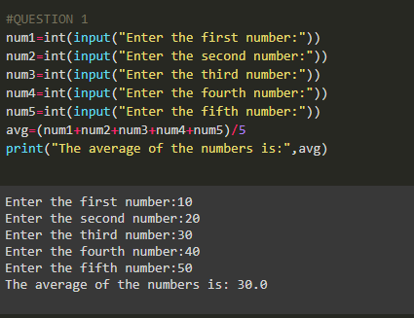

***QUESTION 2)*** ***Write a program to display age of Mayur after 15 years.***

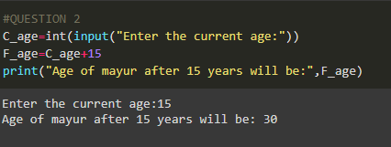

***QUESTION 3)*** ***Write a program to take user input to find x to power n.***

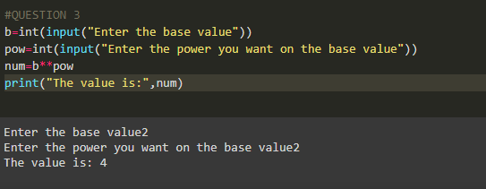

***QUESTION 4)*** ***Write a program to find the area of different plane shapes.***

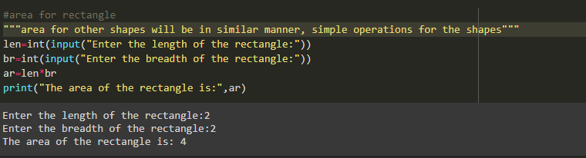

***QUESTION 5)*** ***Write a program to swap values of two variables***.

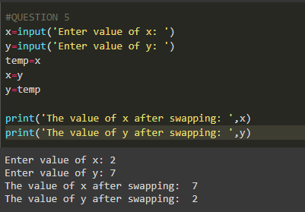

ASSIGNMENT 3

***QUESTION 1)***

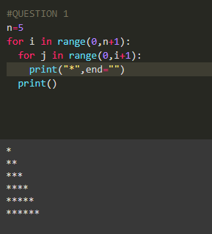

***QUESTION 2)***

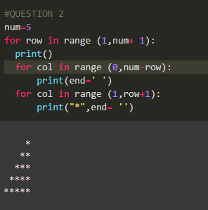

***QUESTION 3)***

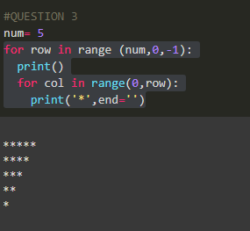

***QUESTION 4)***

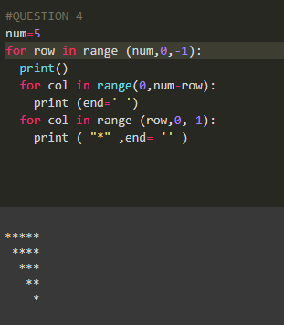

***QUESTION 5)***

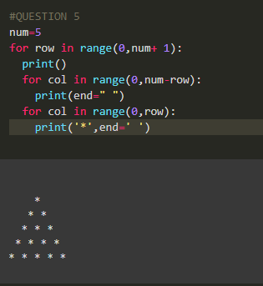

***QUESTION 6)***

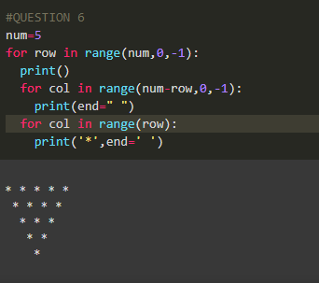

***QUESTION 7)***

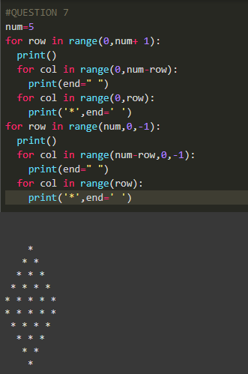

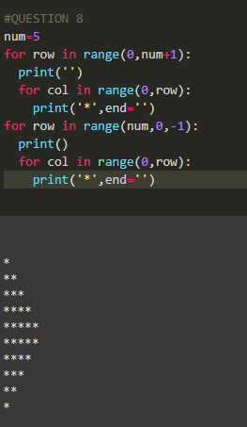***QUESTION 8)***

***QUESTION 9)***

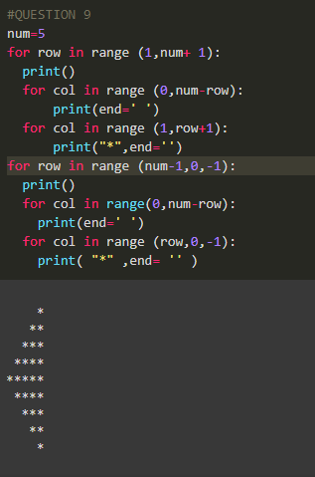

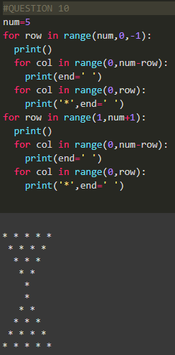***QUESTION 10)***

***QUESTION 11)***

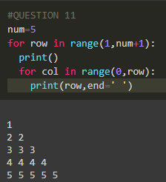

***QUESTION 12)***

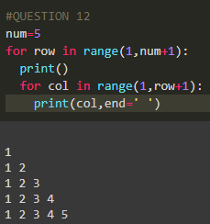

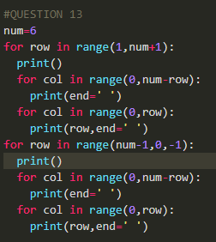***QUESTION 13)***

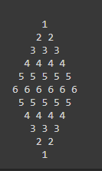

***QUESTION 14)***

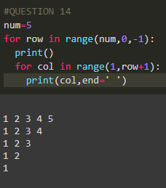

***QUESTION 15)***

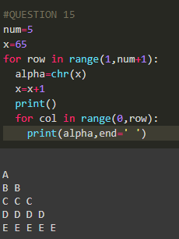

***QUESTION 16)***

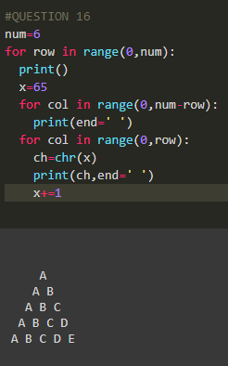

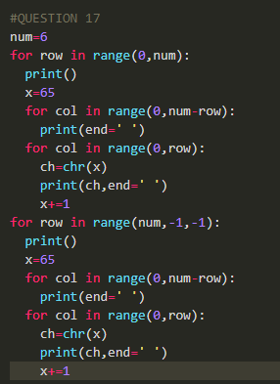***QUESTION 17)***

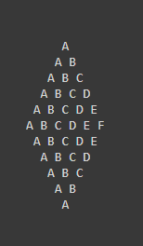

***QUESTION 18)***

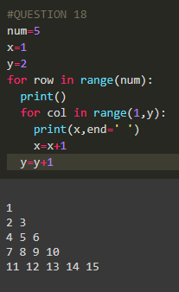

***QUESTION 20)***

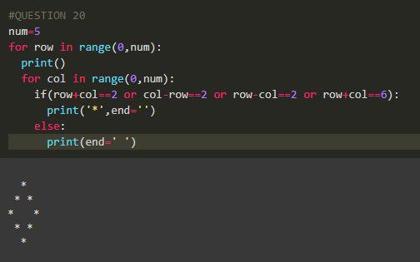

ASSIGNMENT 4

***QUESTION 1)***

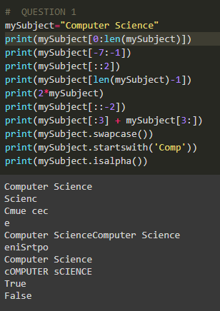

***QUESTION 2)***

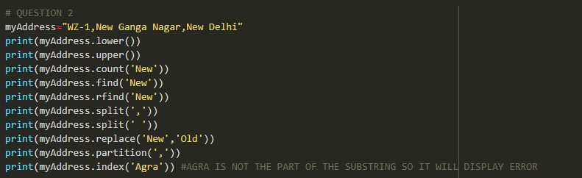

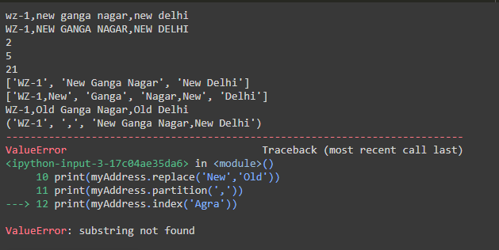

***QUESTION 3)***

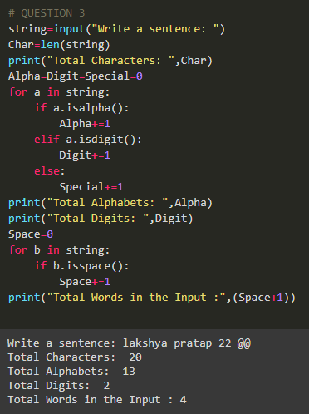

***QUESTION 4)***

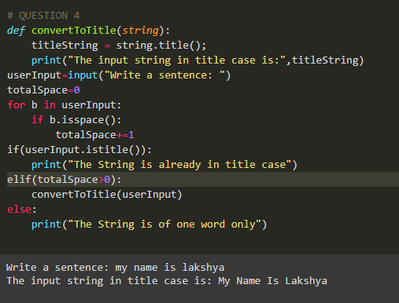

***QUESTION 5)***

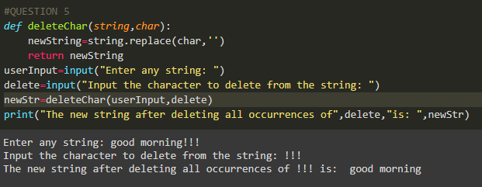

***QUESTION 6)***

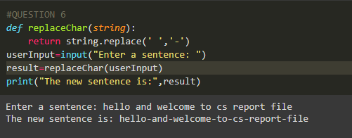

***QUESTION 7)***

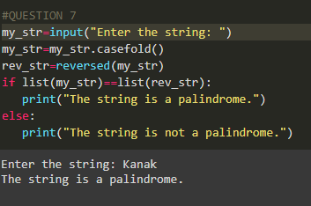

***QUESTION 8)***

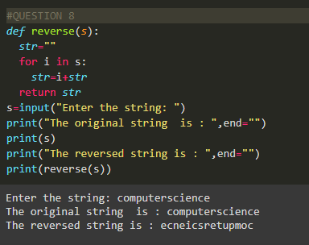

***QUESTION 10)***

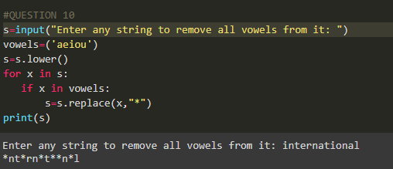

**NAME- LAKSHYA PRATAP SINGH**

**CLASS- XI-B**

**Roll No- 15**